ENAMEL STRIPPING
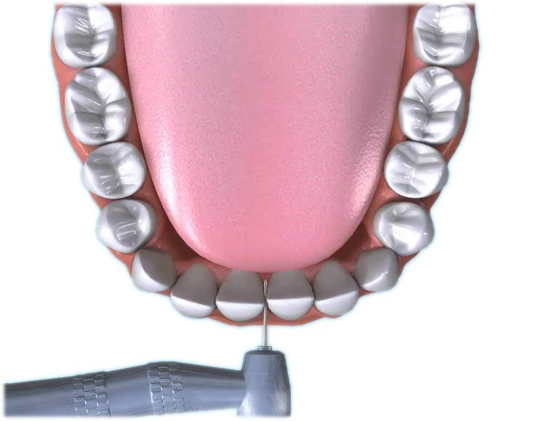

Q Can teeth be straightened without removing other healthy teeth?

A If there is only mild overcrowding of 2-4mm then the teeth can be straightened without removing healthy teeth.

Q What is enamel stripping?

A Enamel stripping is where the teeth are reduced very slightly in width by removing some of the enamel layer.

Q Will it hurt?

A Removing some of the enamel does not hurt.

Q How many teeth will need to be treated?

A Depending on the space required enamel stripping is usually carried out on the six front teeth.

Q Will I still need a retainer?

A Once the space has been created by the enamel stripping process,
the teeth will need to be brought
into line with a fixed brace. Bonded retainers are often fitted after the enamel stripping and fixed brace procedures. These are fitted for permanent retention.

Q How long will the fixed brace need to be in place?

A The amount of time the fixed brace will need to be in place depends on a number of factors, e.g. the amount of teeth that need to be moved etc, therefore, each case is individual. Your orthodontist will advise you accordingly. The bonded retainer applied after removal of the fixed brace should be considered permanent.

Q Will there be any permanent damage?

A Enamel stripping only removes some of the tooth’s enamel, therefore, there should be no long term damage.

Q Is the treatment permanent, or will I need additional future treatment?

A The need for any additional future treatment depends on whether any growth changes occur in the mouth. Regular check ups with your family dentist will highlight these.

